Name:

Year | Course:

Date: October 20, 2022 – **Deadline will be TODAY at 11:59AM**

This must be the name of your word document – LASTNAME_INITIAL(SE_MID2) **TUNGUL_RD(SE_MID2)**

**(Midterm – Activity 2) Inspiration Page**

Add the missing text and images using CSS. Kindly, compare the original example design to the completed one.

1. Problem#1: Missing hashtags
2. Problem#2: Missing Instagram Icon at the top of the image
3. Problem#3: Missing video icon/image at the center of the image

**Default output:**

**Expected output:**

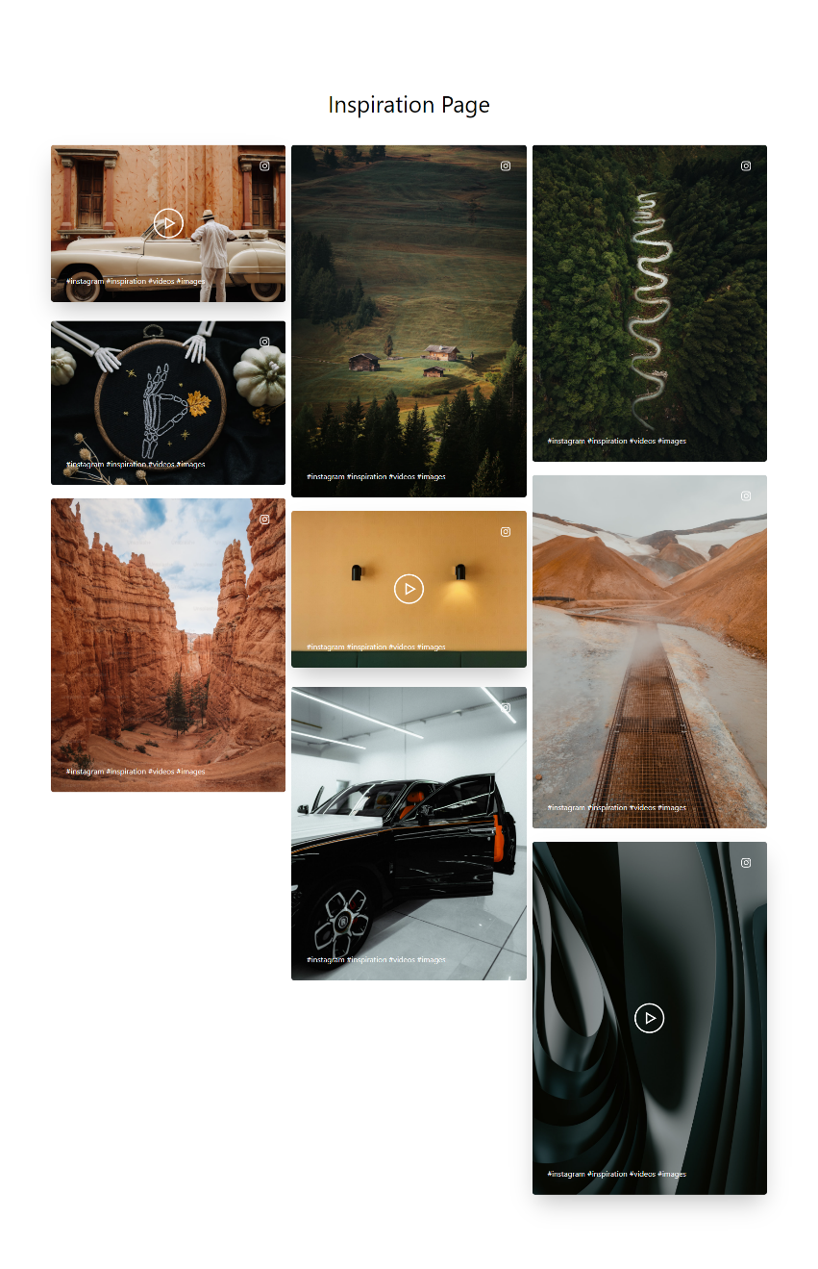

Explain the following problem on how you resolve them. DO NOT ANSWER IN CHORUS.

1. Problem#1: Missing hashtags
2. Problem#2: Missing Instagram Icon at the top of the image
3. Problem#3: Missing video icon/image at the center of the image

Goodluck and keep going! You can do it!

___________________

**Roseph Darl Tungul**

Instructor